Lab5 CIS43 Due: 6/29/2016

Name: Nikhil Vytla

***Exercise: Ex 6.20, 6.22, 6.25, 6.30***



Circle

**package** P620;

**import** java.util.Scanner;

**public** **class** Circle {

**public** **static** **void** main(String[] args) {

Scanner input = **new** Scanner(System.*in*);

System.*out*.print("Input radius of circle: ");

**double** radius = input.nextInt();

**double** area = *circleArea*(radius);

System.*out*.println("Area of the circle is: " + area);

}

**public** **static** **double** circleArea(**double** radius){

**double** c = Math.*PI* * Math.*pow*(radius, 2);

**return** c;

}

}

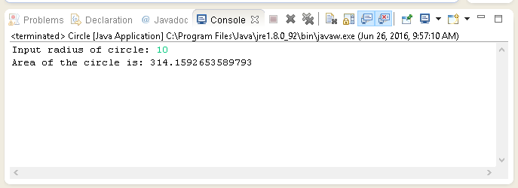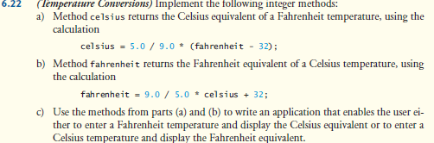

Temperature

**package** P622;

**import** java.util.Scanner;

**public** **class** Temperature {

**public** **static** **void** main(String[] args) {

Scanner input = **new** Scanner(System.*in*);

System.*out*.printf("Type 1 to convert from Fahrenheit to Celsius %n");

System.*out*.printf("Type 2 to convert from Celsius to Fahrenheit %n");

**int** in = input.nextInt();

**switch**(in){

**case** 1:

System.*out*.print("Enter a temperature in Fahrenheit: ");

**double** f = input.nextDouble();

**double** tempc = *celsius*(f);

System.*out*.printf("The temperature in degrees Celsius is: %.2f", tempc);

**break**;

**case** 2:

System.*out*.print("Enter a temperature in Celsius: ");

**double** c = input.nextDouble();

**double** tempf = *fahrenheit*(c);

System.*out*.printf("The temperature in degrees Fahrenheit is: %.2f", tempf);

**break**;

}

}

**public** **static** **double** celsius(**double** f){

**double** c = 5.0 / 9.0 * (f - 32);

**return** c;

}

**public** **static** **double** fahrenheit(**double** c){

**double** f = 9.0 / 5.0 * c + 32;

**return** f;

}

}

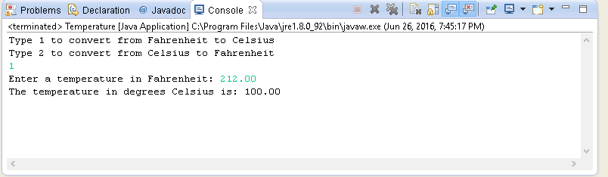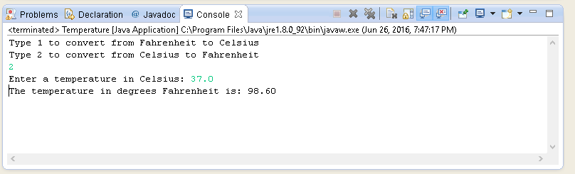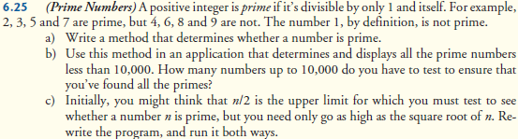

PrimeNumbers (with upper limit num / 2)

**package** P625;

**public** **class** trials {

**public** **static** **int** is_num_prime(**int** num){

**int** is_prime = 1;

**for** (**int** i = 2; i <= num / 2; i++){

**if** (num % i == 0){

is_prime = 0;

**break**;

}

}

**return** is_prime;

}

**public** **static** **void** main(String[]args){

**for**(**int** num = 2; num < 10000; num++){

**int** prime = *is_num_prime*(num);

**if** (prime == 1){

System.*out*.println(num);

}

}

}

}-------------------------------------------------

PrimeNumbers (with upper limit Math.sqrt(num))

**package** P625;

**public** **class** trials {

**public** **static** **int** is_num_prime(**int** num){

**int** is_prime = 1;

**for** (**int** i = 2; i <= Math.sqrt(num); i++){

**if** (num % i == 0){

is_prime = 0;

**break**;

}

}

**return** is_prime;

}

**public** **static** **void** main(String[]args){

**for**(**int** num = 2; num < 10000; num++){

**int** prime = *is_num_prime*(num);

**if** (prime == 1){

System.*out*.println(num);

}

}

}

}

**\*(SAME RESULT BOTH WAYS)\***

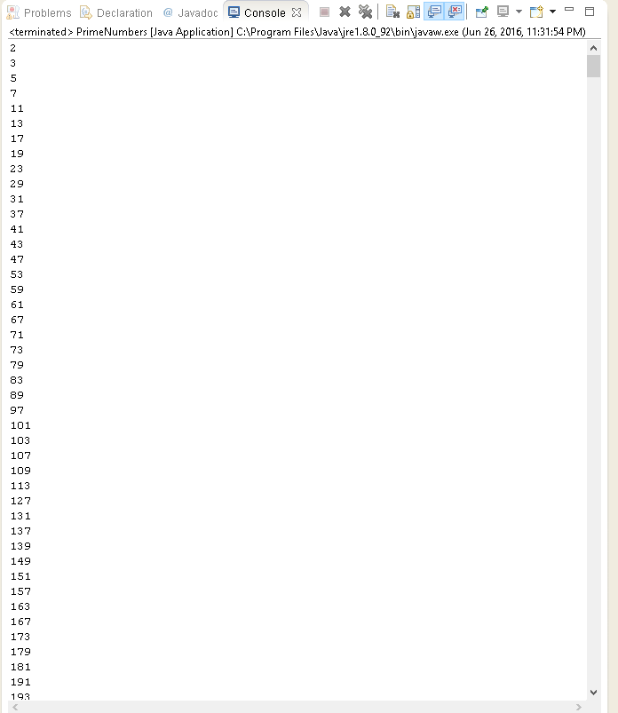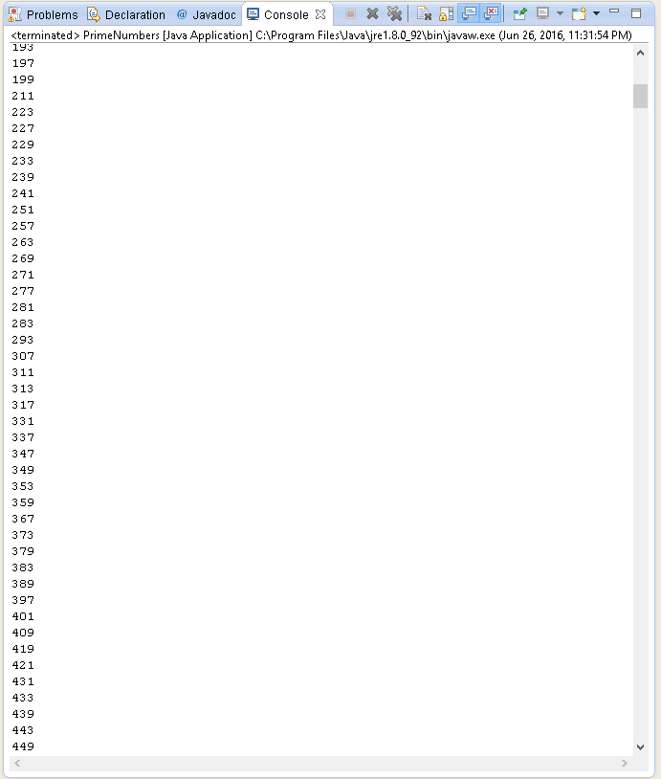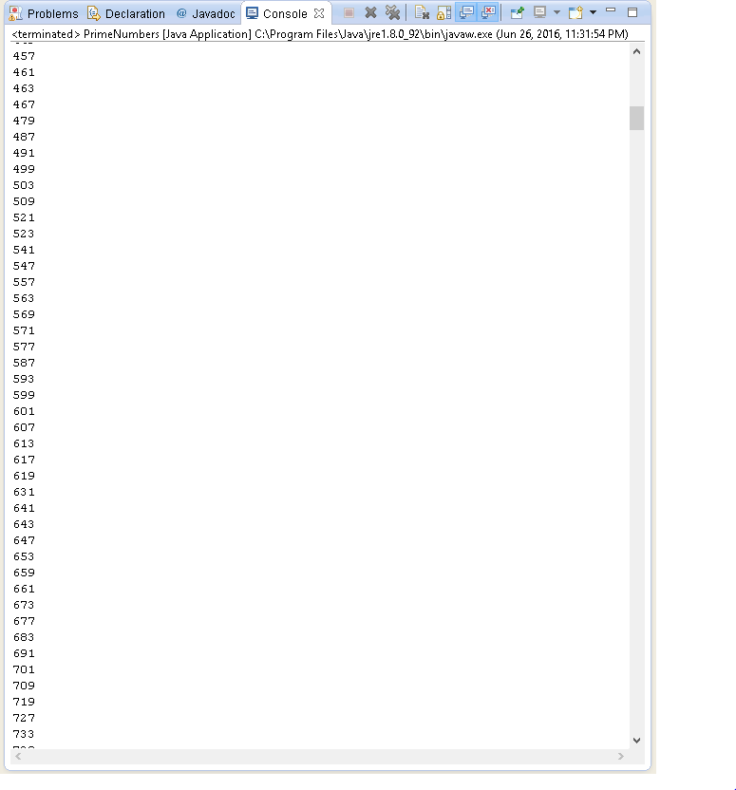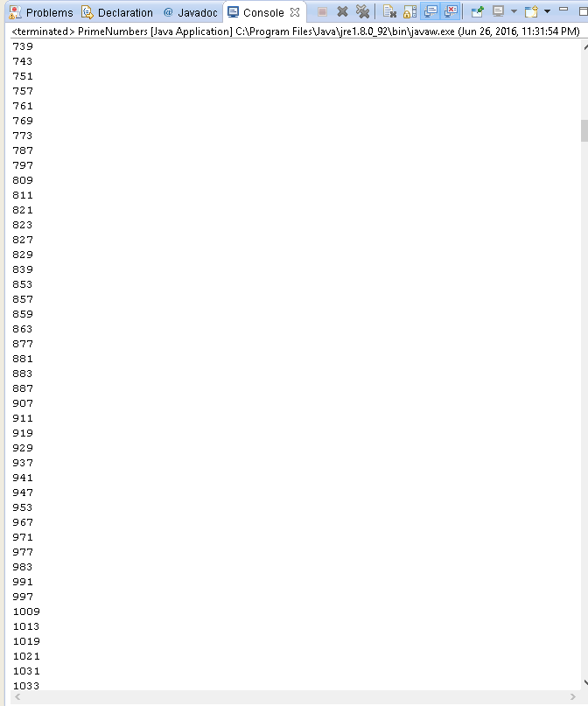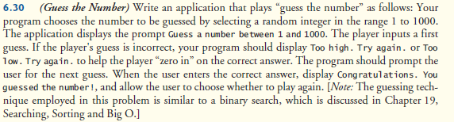

GuessNumbers

**package** P630;

**import** java.security.SecureRandom;

**import** java.util.Scanner;

**public** **class** GuessNumbers {

**private** **enum** Status{ *CONTINUE*, *WON* };

**public** **static** **void** main(String[] args) {

Status gameStatus = **null**;

SecureRandom rng = **new** SecureRandom();

Scanner input = **new** Scanner(System.*in*);

**int** num;

**while** (**true**){

num = 1 + rng.nextInt(1000);

System.*out*.print("Guess a number between 1 and 1000: ");

**int** guess = input.nextInt();

**if** (guess < num){

System.*out*.println("Too low. Try again.");

gameStatus = Status.*CONTINUE*;

}

**else** **if** (guess > num){

System.*out*.println("Too high. Try again.");

gameStatus = Status.*CONTINUE*;

}

**else**

gameStatus = Status.*WON*;

**while** (gameStatus == Status.*CONTINUE*)

{

System.*out*.print("Guess a number between 1 and 1000: ");

guess = input.nextInt();

**if** (guess < num){

System.*out*.println("Too low. Try again.");

gameStatus = Status.*CONTINUE*;

}

**else** **if** (guess > num){

System.*out*.println("Too high. Try again.");

gameStatus = Status.*CONTINUE*;

}

**if** (guess == num)

gameStatus = Status.*WON*;

}

**if** (gameStatus == Status.*WON*){

System.*out*.println("Congratulations. You guessed the number!");

System.*out*.println("Press 1 to play again.");

**int** response = input.nextInt();

**if** (response != 1){

**break**;

}

}

}

}

}

